**Project Pizza House**

**Aim:**

To implement a chatbot for a pizza shop which should be able to interact with customer for placing order, shows the pizza list with addons and track order after the placing of order.

**Architecture:**

In ref: (fig 1) the architecture of the chatbot application describes the complete flow and the module responsibilities of the system.

**Graphical User Interface:**

The GUI is the first interaction page for the users to interact with the chatbot, I have designed the interface in the HTML and CSS. Angular is used to receive and handle events from the GUI to communicate with backend.

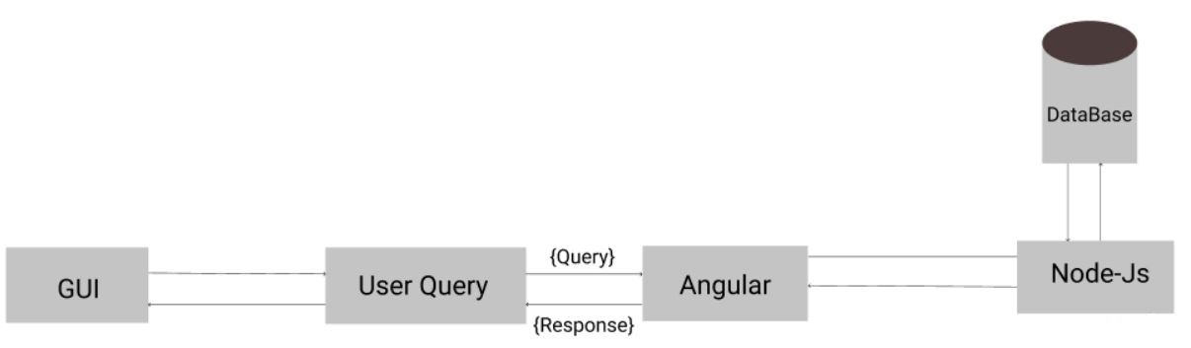

Fig1: System Architecture

**Angular:**

The user query and events are decision logic is written in the angular service file, the decision will be taken based on the user respective button click or the user query, depending on the decision logic I have written decision will be take to perform on the backend.

**Node js:**

Using cross origin connecting the angular as front end and node-js as backend, which connects the angular request to database via node API’s to store new user, pizza order, and track order.

**Database:**

Used mysql for the data storage, which is required to store the user data and order details.

**Flow Diagram:**

The system has button to place order and track order in the GUI, from the initial start we have two buttons loaded for user, 1. To order pizza and 2. Track my order. Based on the choice of the user the system will lead the flow to till the end where placing the order for the user and provide a order id to track.

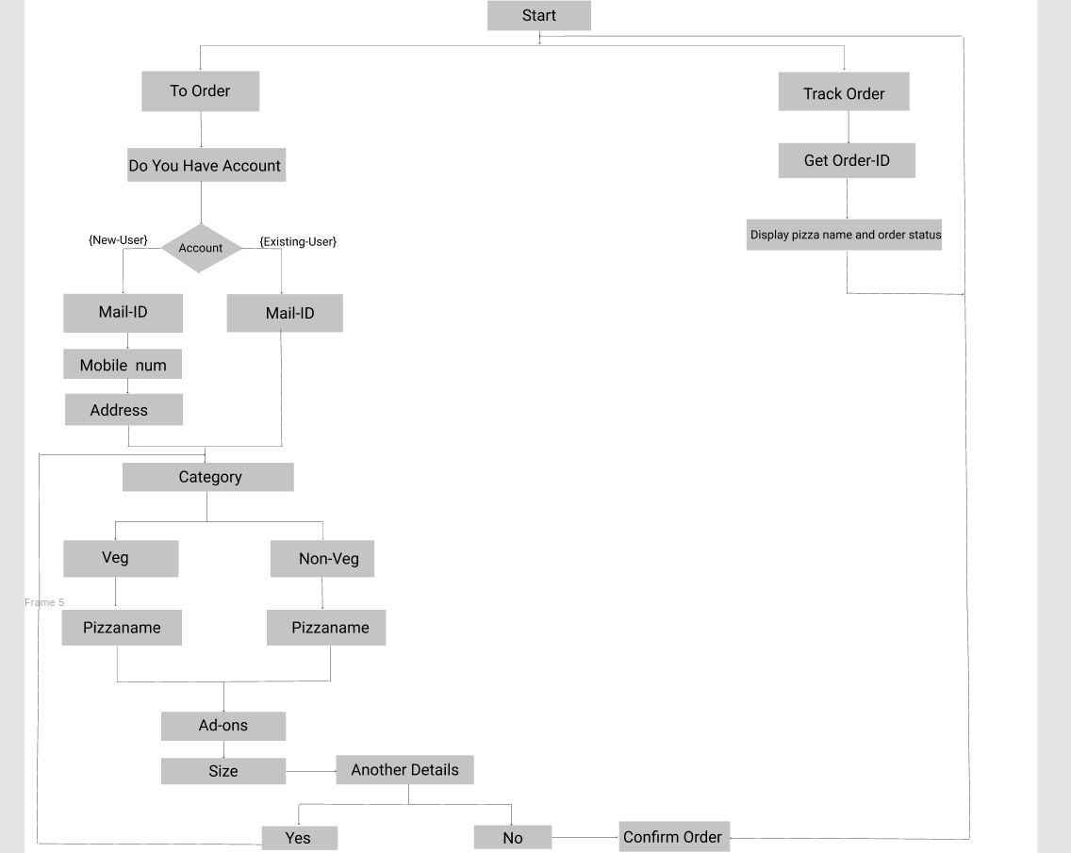

Fig 2: Flow diagram

**Development and deployment environment:**

Front end : HTML/CSS, Angular 8

Back end : Node js 15.04

Database : MySQL

Deployment : Amazon web service

IP address : <http://18.216.200.254>

Browser : Google chrome, Microsoft Edge.